PROVISIONAL MARKING KEY FOR PRACTICAL AGRICULTURE

1. a. Calculate price elasticity of demand between January and February

ED = Change in quantity demanded×original price
______________________________________
 | Change in price×original quantity |  |  | (1 mark)
 | = (15,000 – 13,000) × 10,000
 | _______________________________ × 10,000 |  |  | (1 mark)
 | 10,000 – 11,000 |  | 15,000
 | = 2000×10,000 |  |  | (1 mark)
 | ________________________
 | 1000×15, 000
 | = 1.33 |  |  | (1 mark)
b. Elastic demand |  |  |  | (1 mark)

c.

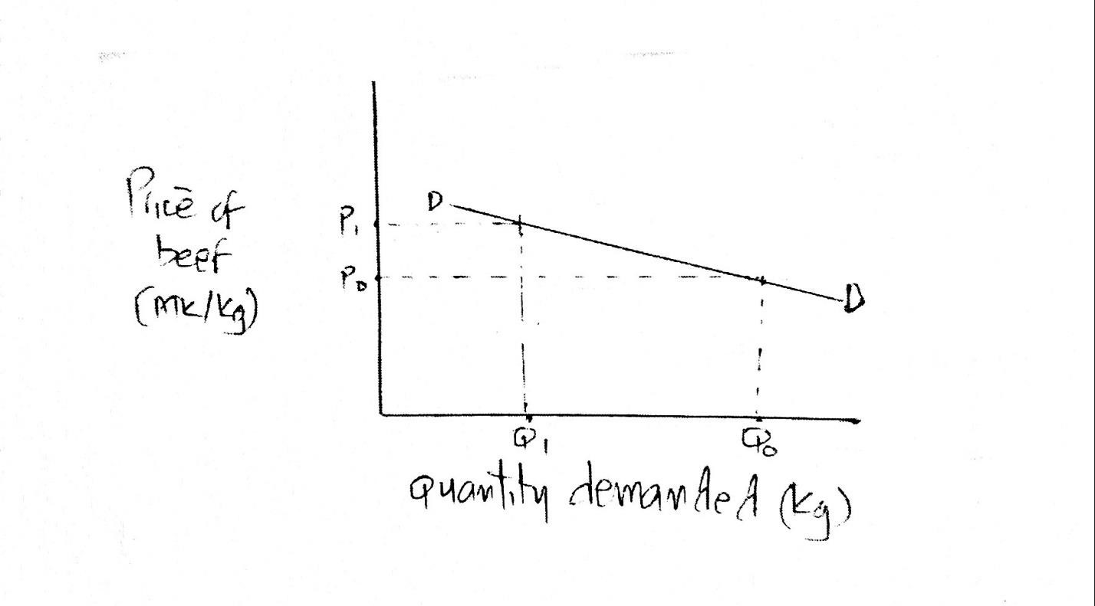
1 mark for giving all details on Y axis
- mark for giving all details on X axis
- marks for correct line graph (2 coordinates)

d. Implications of price elasticity of demand
Assist farmers in making right decisions/ weather to raise or reduce price of commodities
If the price of a product with elastic demand increases/ people will buy a related commodity
A reduction in price will increase demand/ leading to a decrease in supply
Farmers remain poor / despite high production
(2 marks) for any 1 point

- Chop the material into smaller length/ this will help to increase surface for easy colonization of mushroom

Soak them in water for few hours/ to soften them and make them suitable for colonization

Drain them from the water/ to prevent them from contamination if there is too much water

Add supplement to the substrates/ this helps the substrates to have more nutrients

Treat the substrates/ through sterilization or pasteurization to eliminate pathogens

(10 marks) for any 5 points

- a.
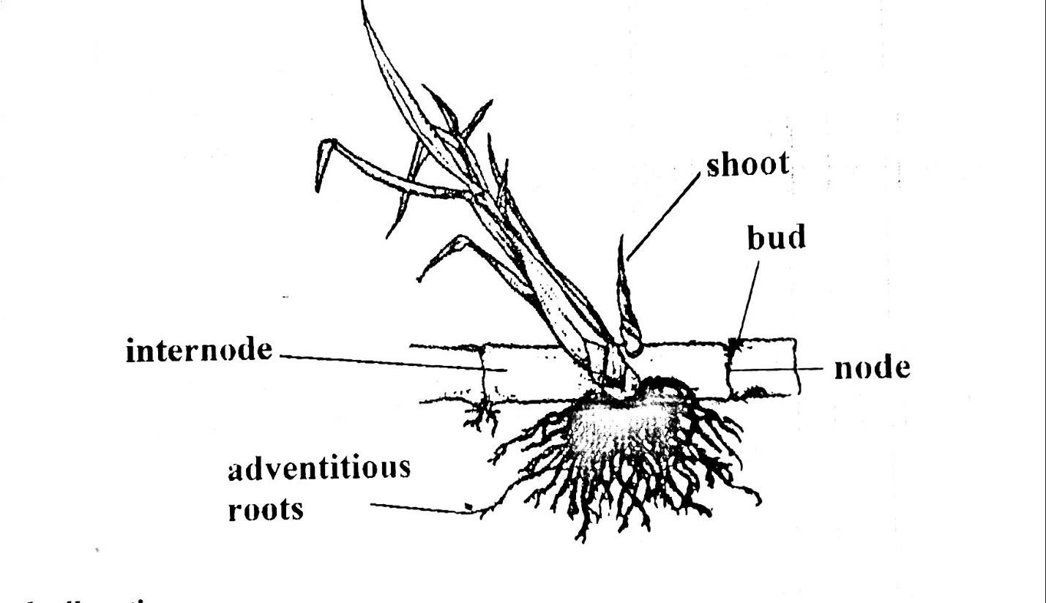
Mark allocation
1 mark for correct drawing
1 mark for each correctly labelled part

- it has large food storage (1 mark)
- it fixes nitrogen in the soil which later is used by plants (1 mark)
- Concentrates (1 mark)

- Two nutrients found in specimen M
  - lipids (fats and oil)
  - Proteins
- planting it along water ways (grassed water ways)
Include it strip cropping
Planting it in steep slopes
Planting it in contours

4. a. i. Sample C (1 mark) ii. Sample D (1 mark) iii. it has higher water holding capacity (1 mark)

b. two factors to consider when choosing an irrigation system
    - topography
    - type of soil
    - availability of water
    - value of the crop (2 marks)
- Two uses of a complete budget
  - when a farmer wants to open a new farm
  - when a farmer wants to make major changes on the farm
- Importance of supplements in livestock feeds
  - improves immunity of livestock
  - stimulates growth
  - controls pests and diseases

